MANAGEMENT OF COVID 19
טיפול נמרץ כללי
הטיפול היעיל ביותר והטיפול היחיד שהוכח שעובד בחולי COVID 19 הוא אכפתיות ,מסירות וטיפול תומך מסיבי.

Mildly to Moderately Symptomatic patients
מחלה קלה
- תסמיני קורונה (חום, שעול, כאב גרון, חולשה, כאב ראש, כאב שרירים, בחילה, הקאה, שלשול, אבדן טעם וריח, נזלת), ללא תסמינים נשימתיים (קוצר נשימה או צילום חזה פתולוגי)
מחלה בינוני
- עדות למעורבות של מערכת הנשימה התחתונה בבדיקה גופנית או בהדמייה של צל"ח, עם סטורציה מעל 94% באויר חדר.

- Vitamin C 500mg x 2 PO
- Zinc 50-100mg/day PO
- Vitamin D3 1000-4000u/day PO
- Enoxaparin 40-60mg sc /day (adjust dose if Cr Clearance < 30ml/min)
- Oxygen supplimentation via nasal prongs (1-6 l/min) to maintain saturation above 92%.

- חולים עם מחלה קלה-בינונית שאינם מאושפזים ונמצאים בסיכון גבוה להתקדמות המחלה
  - (BMI > 35, סוכרת, CRF, מערכת חיסונית ירודה, גיל > 65 שנים, > 55 עם CVD , יתר לחץ דם או Chronic Respiratory Disease)
  - לשקול מתן טיפול בנוגדנים מונוקלונליים:
o Bamlanivimab 700mg & Etesevimab 1400 mg
Or
o Casirivimab 1200mg & Imdevimab 1200mg (Regen-Cov)

יש לתת את הטיפול במהירות האפשרית לאחר זיהוי המחלה, ולא יאוחר מיום 10 מתחילת התסמינים

Severely to Critically ill symptomatic patients
מחלה קשה
- סטורציה מתחת ל- 94% באויר חדר, יחס PaO2/FiO2 <300, או קצב נשימות מעל 30 בדקה, או תסנינים מעל 50% משדות הראה בצילום חזה
מחלה קריטית
- אי ספיקה נשימתית, הנשמה, שוק ספטי, פגיעה רב מערכתית.
- Vitamin C 500mg x 2 PO
- Severely ill – iv Vitamin C 1.5g x 4 + thiamine 100mg x 2 + steroids
- Zinc 50-100mg/day PO
- Vitamin D3 1000-4000u/day PO
- Esomeprazole 20mg x 1 PO.
  - If patient absorbing feeds, esomeprazole is not necessary unless indicated for specific reason.
  - Not absorbing feeds – iv esomeprazole 40mg x 1
- Enoxaparin 40-60mg sc /day if no contraindications
  - adjust dose if Cr Clearance < 30ml/min
- Consider full anticoagulation if D Dimer > 20ug/mL , fibrinogen > 900mg/dL, Ferriten > 1000mcg/L or CRP > 100mg/L and there is no contraindication to anticoagulation :
  - with enoxaparin 1mg/kg x 2 ( if Cr clearnace >30ml/min)
  - with UFH if Cr clearance <30ml/min (target PTT 80-100seconds)
- Steroids
  - Recommended by senior doctor
  - Methylprednisolone 1mg/kg loading dose followed by continuous infusion of methylprednisolone 1mg/kg/day
    - במשך 5 ימים ואז לפי התגובה של החולה לשקול להוריד את המינון בהדרגה ( כל יומיים)
    - שחולה סופג ניתן לתת פרדניזון פומי/דרך הזונדה, במקום סולומדרול, במינון מקביל
alternatively
  - Dexamethasone 6mg x 1 x 10days
- Remdesivir - (רק לפי המלצות זהומולוגים)
  - Indicated in patients requiring oxygen
  - Dose
    - Loading dose: iv remdesivir 200mg on day 1
    - Maintenance dose: iv remdesivir 100mg x 1 (day 2 to day 5)
    - If no improvement after 5 days treatment , give for a further 5 days
    - Contraindications for remdesivir
      - GFR < 30ml/min
      - Liver failure
  - Dissolve remdesivir in 250cc NaCl 0.9% and give intravenously over 1 to 2 hours.

- Fluids to maintain euvolemia
  - Due to "flu-like" symptoms patients may be volume depleted. Cautious fluid replacement with 500ml boluses (fluid challenges) of ringer's lactate (suitable fluid if electrolyte abnormality) may be warranted.
- Nutrition – PO, PZ, parenteral (בהתיעצות עם דיאטנות)
  - Monitor
    - Pulse rate
    - BP (Systolic, diastolic and mean)
    - Respiratory rate
    - Saturation
    - Urine output
    - Blood tests
      - CBC, BUN , Cr, LFTs, albumin, triglycerides, INR, D Dimer, fibrinogen, CRP, ferritin, electrolytes, CPK, LDH, blood gases, lactate
  - Dynamic hemodynamic monitoring
    - Pulse pressure variation (ventilated patient)
    - Stroke volume variation (ventilated patient)
    - IVC collapsibility (ventilated patient)
    - Passive leg raising
    - ScvO₂
- Early vasopressor support
- Antibiotics after consulting with ID physician

Experimental treatments
- Remdesivir
  - No benefit in those on HFNCO, NIV, MV or ECMO
- Kaletra – lopinavir/ritonavir
  - Protease inhibitor which prevents viral replication
  - No evidence to support use in COVID 19
- Ivermectin
  - No evidence to support use in COVID 19
- Tocilizumab {actemra} (anti-IL-6 receptor monoclonal antibodies)
  - single intravenous dose of tocilizumab 8 mg/kg actual body weight up to 800 mg in combination with dexamethasone (6 mg daily for up to 10 days)
  - Indications for Tocilizumab
    - Recently hospitalized patients (i.e., within first 3 days of admission) who have been admitted to the intensive care unit (ICU) within the prior 24 hours and who require invasive mechanical ventilation, noninvasive ventilation, or high-flow nasal canula (HFNC) oxygen (>0.4 FiO₂/30 L/min of oxygen flow)
    - Recently hospitalized patients (i.e., within first 3 days of admission) not admitted to the ICU who have rapidly increasing oxygen needs and require noninvasive ventilation or HFNC oxygen and who have significantly increased markers of inflammation (CRP ≥75 mg/L)
    - For hospitalized patients with hypoxemia who require conventional oxygen therapy, there is insufficient evidence to specify which of these patients would benefit from the addition of tocilizumab.
  - Contraindications :
    - significantly immunosuppressed, particularly in those with recent use of other biologic immunomodulating drugs
    - alanine aminotransferase >5 times the upper limit of normal
    - high risk for gastrointestinal perforation
    - an uncontrolled serious bacterial, fungal, or non-SARS-CoV-2 viral infection
    - absolute neutrophil count <500 cells/µL
    - platelet count <50,000 cells/µL
    - hypersensitivity to tocilizumab.
- Other Anti IL 6 receptor monoclonal antibodies
  - Sarilumab – can be used if iv tocilizumab is not available.
- Anti IL 6 monoclonal antibodies – not recommended
  - Siltuximab
- Convalescent Plasma
  - Insufficient data to support convalescent plasma.
  - Our experience is worsening of respiratory status after receiving FFP
- Mesenchymal Stem Cells
  - Not recommended
- Interleukin 1 inhibitors
  - Anakinra
    - Not recommended
- Interferons (alfa or beta) – not recommended
- Bruton,s tyrosine kinase inhibitors – not recommended
  - Acalabrutinib
  - Ibrutinib
  - Zanubrutinib
- Janus kinase inhibitors
  - Baricitnib
    - Can be used in recently hospitalized patients with rapidly increasing oxygen needs and systemic inflammation if iv tocilizumab is not available.
  - Ruxolitnib
  - tofacitnib

Escalation of respiratory support
- SpO₂ > 92% (Accept SpO₂ > 88% in some cases (permissive hypoxemia))
- Titrate FIO₂ and/or oxygen flow based on patient's saturation
- Attempt early cooperative prone in the non ventilated patient
- Do not delay intubation and invasive mechanical ventilation if indicated

Low flow nasal cannula - Set at 1 – 6 liters/minute
O₂ mask – venturi , Non rebreathing

High flow nasal cannula oxygen (HFNCO)

CPAP (if PaCO₂ normal)
- 5 – 15cmH₂0

BPAP (if tendency to respiratory acidosis)
          - IPAP 7 – 20cmH₂0
          - EPAP 5 – 15cmH₂0
          - Titrate FIO₂ or O₂ flow according to saturation

Invasive medical ventilation
          - PCV-A/C or PRVC
          - Target tidal volumes 6cc/kg
          - Driving pressure (P_{Plat} – PEEP) < 15cmH₂0
          - Sedation
            - to maintain RASS -3 to -4
          - Trial of nitric oxide
          - Prone position

ECMO
Calculating predicted body weight
Male = 50 +0.91{ht (cm) -152.4}
Female =45.5 + 0.91{ht (cm)-152.4}

Provision of oxygen and deciding to intubate patients with COVID 19

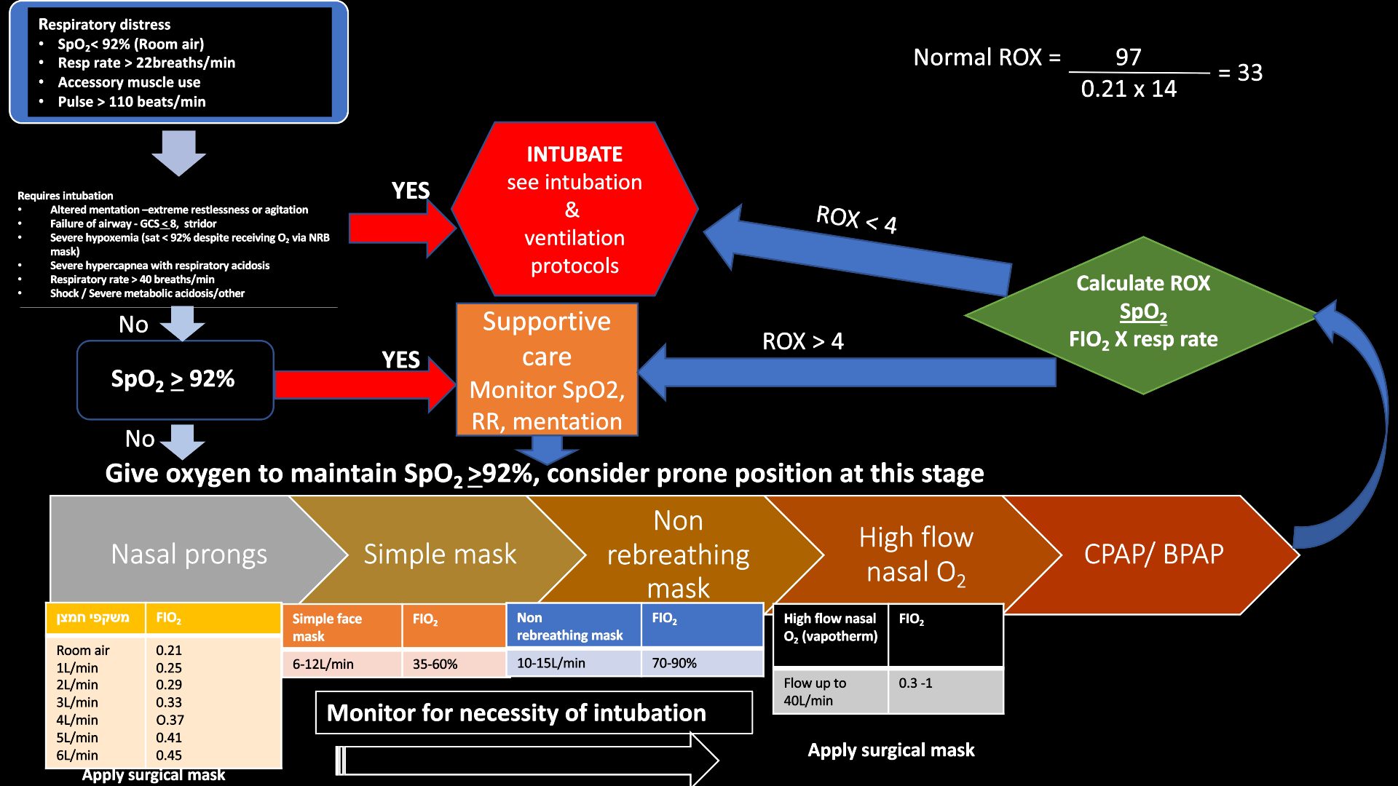

ROX index
The ROX index is defined as the ratio of oxygen saturation as measured by pulse oximetry/FIO₂ to respiratory rate
The ROX index has been assessed as a predictor of the need to intubate in patients received HFNC oxygen therapy.
ROX ≥ 4.88 at 2, 6 and 12 hours after HFNCO initiation was associated with a lower risk for intubation.

Management of acute hypoxic respiratory failure
When to provide
- Oxygen
- HFNCO
- CPAP / NIV
- Intubation
Consider: a trial of CPAP / NIV
Do it: Monitor closely at short intervals
Do not: Delay intubation if worsening

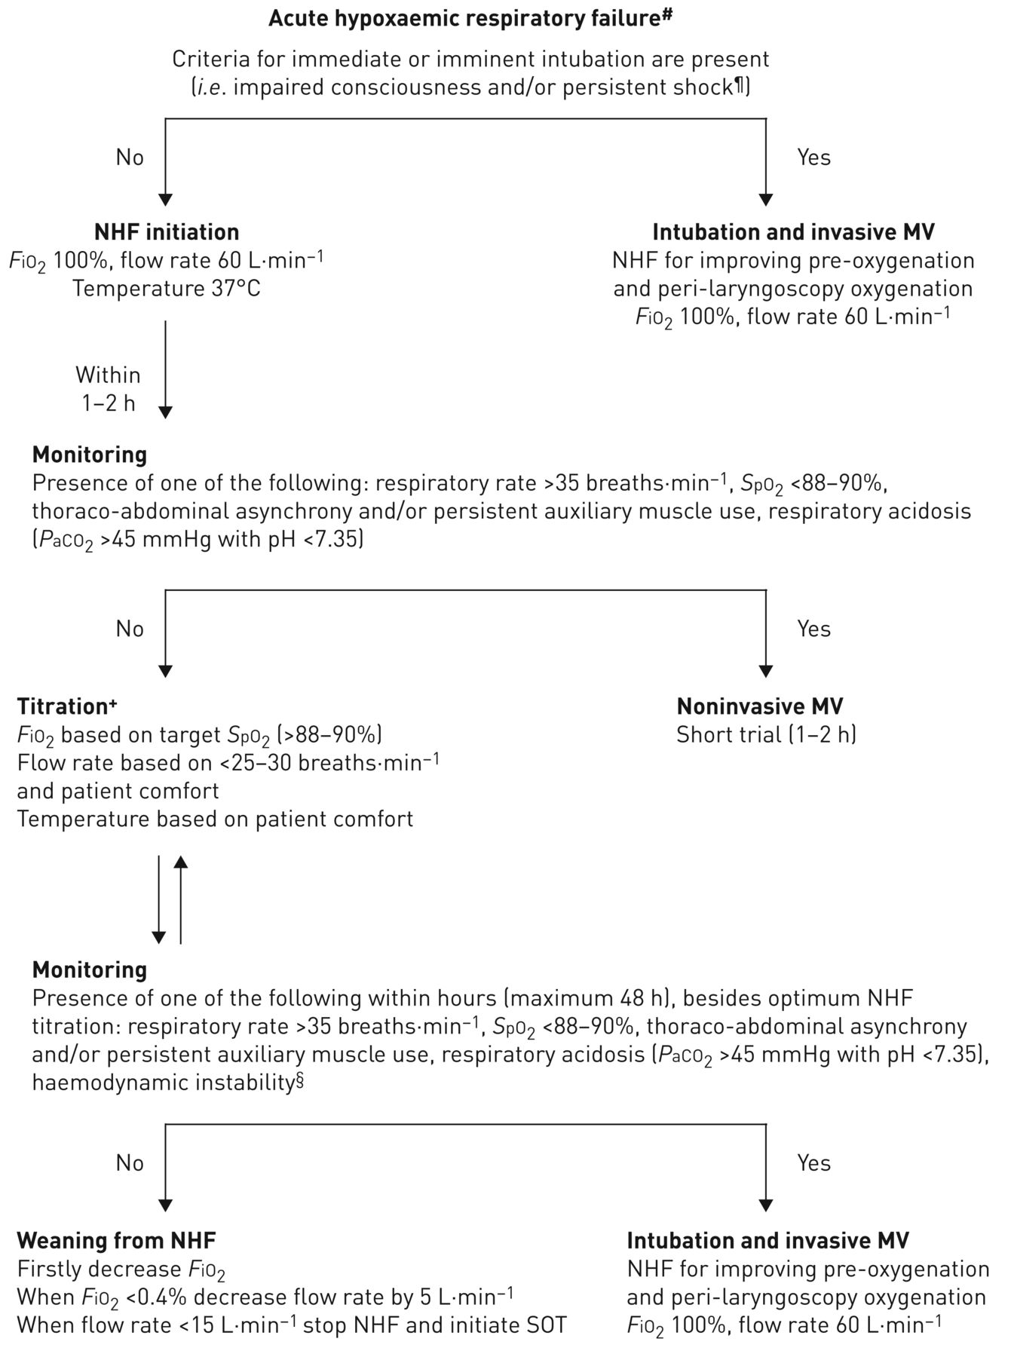
Start with :FIO2 1
:Flow 20L/min. Increase flow by 5L/min every 5 minutes until patient appears comfortable
Temperature setting 36 – 37⁰C

High Flow Nasal Cannula Oxygen

NHF = Nasal High Flow Oxygen

Management of ARDS

Conventional VV ECMO indications for Acute Respiratory Distress Syndrome
- International group of interdisciplinary ECMO providers
  - ASAIO Journal 2020; 66:707–721.

ECMO = extracorporeal membrane oxygenation ; FiO₂ = fraction of inspired oxygen; PaCO₂ = partial pressure of carbon dioxide; PaO₂ = partial pressure of oxygen; PEEP = positive endexpiratory pressure; VV = venovenous

Contraindications for ECMO in COVID-19 Infected Adults

Relative contraindications
- Age ≥ 65 years
- Obesity BMI ≥ 40
- Immunocompromised status
- No legal medical decision maker available
- Advanced chronic underlying systolic heart failure
- High dose vasopressor requirement (and not under consideration for VA or V-VA ECMO)

Absolute contraindications
- Advanced age
- Clinical Frailty Scale category ≥ 3
- Mechanical ventilation > 10 days
- Significant underlying comorbidities:
  - CKD ≥ III
  - Cirrhosis
  - Dementia
  - Baseline neurologic disease which would preclude rehabilitation potential
  - Disseminated malignancy
  - Advanced lung disease
  - Uncontrolled diabetes with chronic end-organ dysfunction
  - Severe deconditioning
  - Protein-energy malnutrition
  - Severe peripheral vascular disease
  - Other preexisting life-limiting medical condition
- Nonambulatory or unable to perform activities
- Severe multiple organ failure
- Severe acute neurologic injury, e.g., anoxic, stroke
- Uncontrolled bleeding
- Contraindications to anticoagulation
- Inability to accept blood products
- Ongoing CPR
BMI = body mass index; CHD = chronic kidney disease; COVID-19 = coronavirus disease 2019;
CPR = cardiopulmonary resuscitation; ECMO =extracorporeal membrane oxygenation;
VA =venoarterial; V-VA = veno-venous arterial.

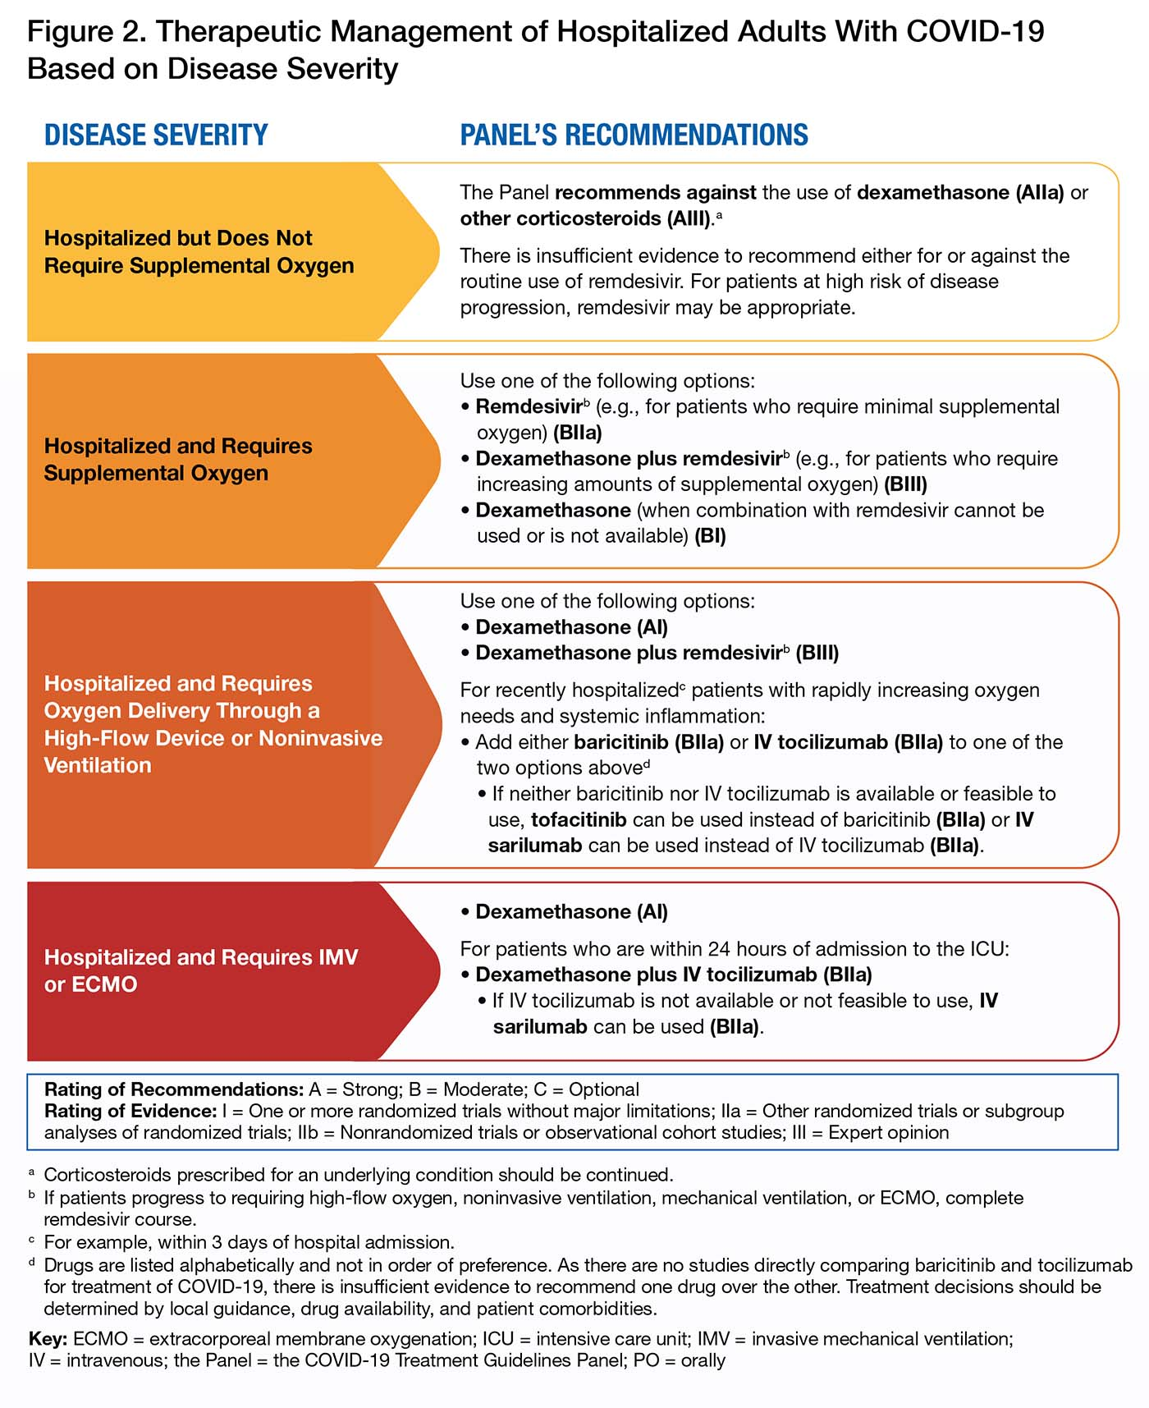
Pharmacological Mx Updated August 25, 2021

